
User’s Manual
May 2010
Version 1.0
Table of Contents:
Overview…………………………………….………………………………………………………………… 3
Requirements ….……….……………….…………………………………………………………………. 4
Installation ..…………………………….…………………..……………………………………….……… 5
Using the Application …………….…………………………………...……….………………………. 6
Login ……………….………………….…………………………………………………………………………………. 6
Business Cases …………………..…………………………………………………………………………………... 7
Add ………………………….…………………………………………………………………………………….. 7
View ……………………………………………………………………………………………………………… 10
Edit ……………………………………………………………….………………………………………………. 11
Delete …………………………………………………………………………………………………………… 12
Projects ……….. ……………………………….…………………………………………………………………….. 13
Add ……………………………….………………………………………………………………………………. 13
View ………………………………………………….…………………………………………………………… 18
Edit …………………………………………………………………….………………………………………….. 19
Delete ……………………………………………………………………………………….…………………… 20
Resources ……..…………………………………………………………………………………………………..….. 21
Add …………………………………………………………………………………………………………….…. 21
View ……………………………………………………………………………………………………………… 22
Edit ……………………………………………………………………………………………………………….. 23
Delete …………………………………………………………………………………………………………... 23
Reports ……………………………………………………………………………………………………….. 24
Work Initiation Plan …………….……….……………………………………………………………………………………. 25
Detailed Roadmap ……………….….………………………………………………………………………………………… 26
Project Timeline …………………..……………………………………………………………………………………………. 26

System Overview
WebPM is a database driven system for tracking and documenting different business cases, projects, and resources maintained at the company. WebPM has a web based client that is accessed through Mozilla Firefox, Microsoft Internet Explorer, or any other supported web browser. The client connects to a Java based server backend that uses database communications to allow users to insert, edit, update, and delete any of the components.
Requirements
WebPM has been designed to be as expandable and platform independent as possible. With that in mind, here is a listing of the required technologies and the technologies we used to create and test the system.
Operating System:
Used | Required
Ubuntu Linux Kernel 2.6.31-19 generic | Any operating system capable of running a web server
Web Server:
Used | Required
Apache web server running Apache Tomcat | Any web server capable of running Java web technologies should be able to run the WebPM system.
Database:
Used | Required
MySQL v5.1 | Any JDBC compliant database should work with WebPM as long as the proper JDBC driver is installed in the web server.
Web Browser:
Used | Required
Firefox | Currently, WebPM only supports the use of Firefox. Javascript must be enabled in the selected browser for the interface to work correctly.

Installation instructions
The WebPM system does not come with an automated installer. Administrative intervention is highly recommended when setting up this system, as it involves direct changes to web server/servlet container configuration, which may be greatly impacted by site policy. As such, this document provides a brief description of this installation process; this process should be taken as guidelines only.
- Given an already existing installation of apache2/tomcat6 or a fresh installation:
  - A sample initialization script is shown in src/tomcat6/init_scripts/tomcat6. This script indicates the necessary changes to environment variables (JAVA_OPTS and JSVC_CLASSPATH) that are required to support WebPM.
  - The library webpmsec.jar must be made accessible to tomcat6 by emplacing it in a directory found in JSVC_CLASSPATH. A pre-compiled version is available in src/jaas/webpmsec.jar. Instructions for compiling this package from source are located in src/README.
  - The file webpm_login.config should be made accessible to tomcat6, and JAVA_OPTS should be updated as necessary.
  - Incorporate 04webapps.policy into your existing tomcat6 security policy.
  - Incorporate server.xml into your existing server configuration.
  - Restart tomcat6.

- Given an already existing MySQL database or a fresh installation:
  - Create a database called “webpm” according to your site policy.
  - “source” the file src/db/init_webpm.sql to create the necessary tables.

- Add name resolution for “webpm” to the IP of the target server at your site. The webpm server must be known as “webpm” and the servlet container service must listen on port 8080.

- Make changes to src/web/build.xml as necessary to match your site policy.
  - Deploy the application to the webpm server using ANT.

- Test your installation by pointing your browser to:
http://webpm:8080/webpm/index.jsp

- Carefully monitor the tomcat6 logging subsystem for potential problems.

Using the Application
Below are the detailed instructions explaining how to use the different components and features of the WebPM system.
Login:
Users are required to log into the system before they are able to create, retrieve, update, or delete information in the system. Different user permissions will grant different rights and abilities to manipulate data within the system.
Upon entering the site, a prompt will appear asking for your name and password.
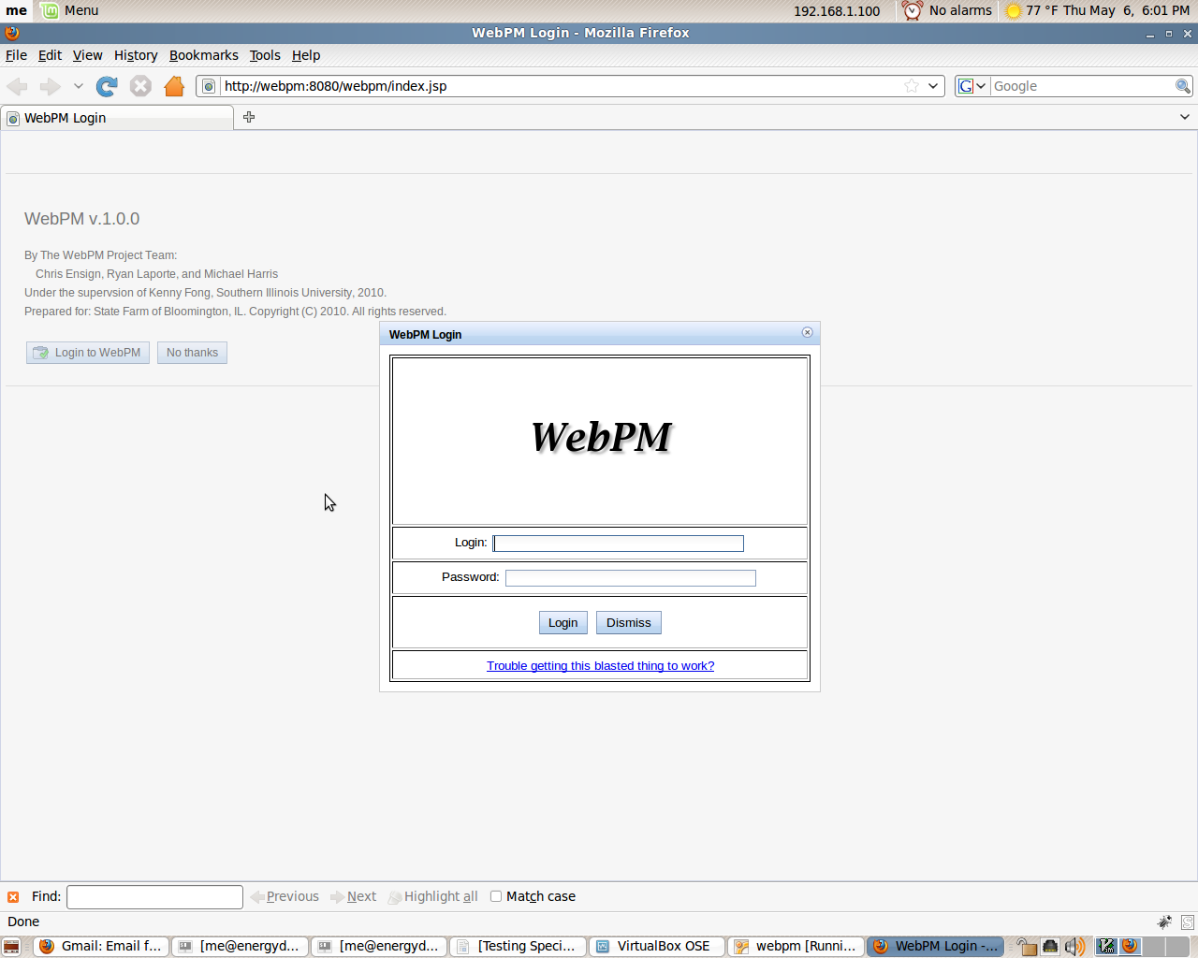
After you enter the needed information, click the “Login” button. When your credentials have been verified, you will be given access to the system.
Business Cases
Add:
To add a business case, click the button at the top left of the page titled “Add Business Case”.
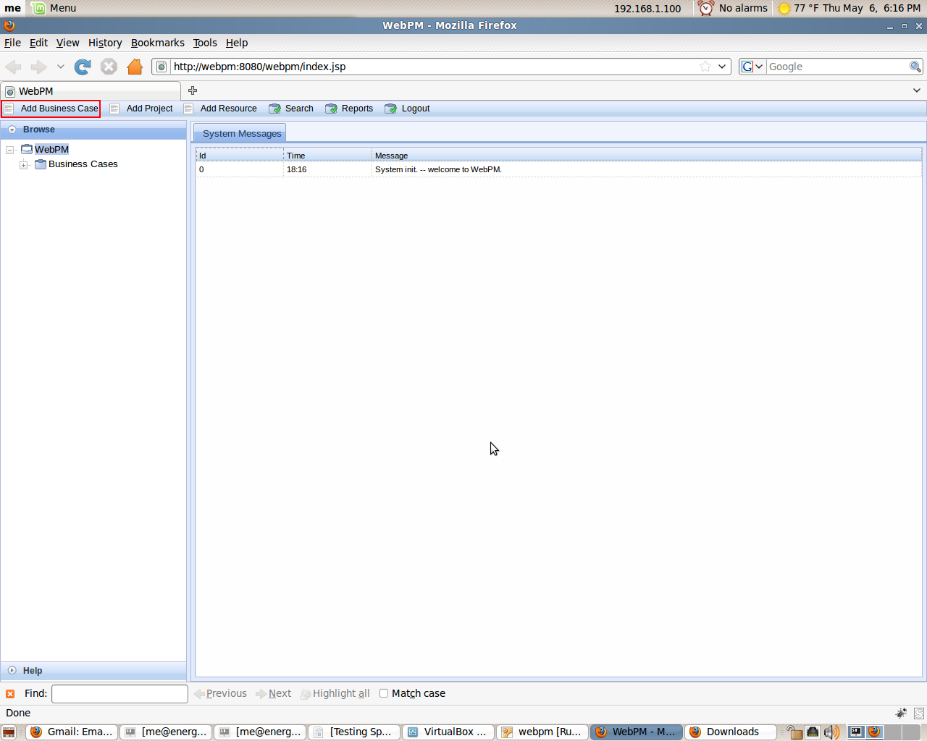
A dialogue window will appear containing fields for necessary information related to the business case.
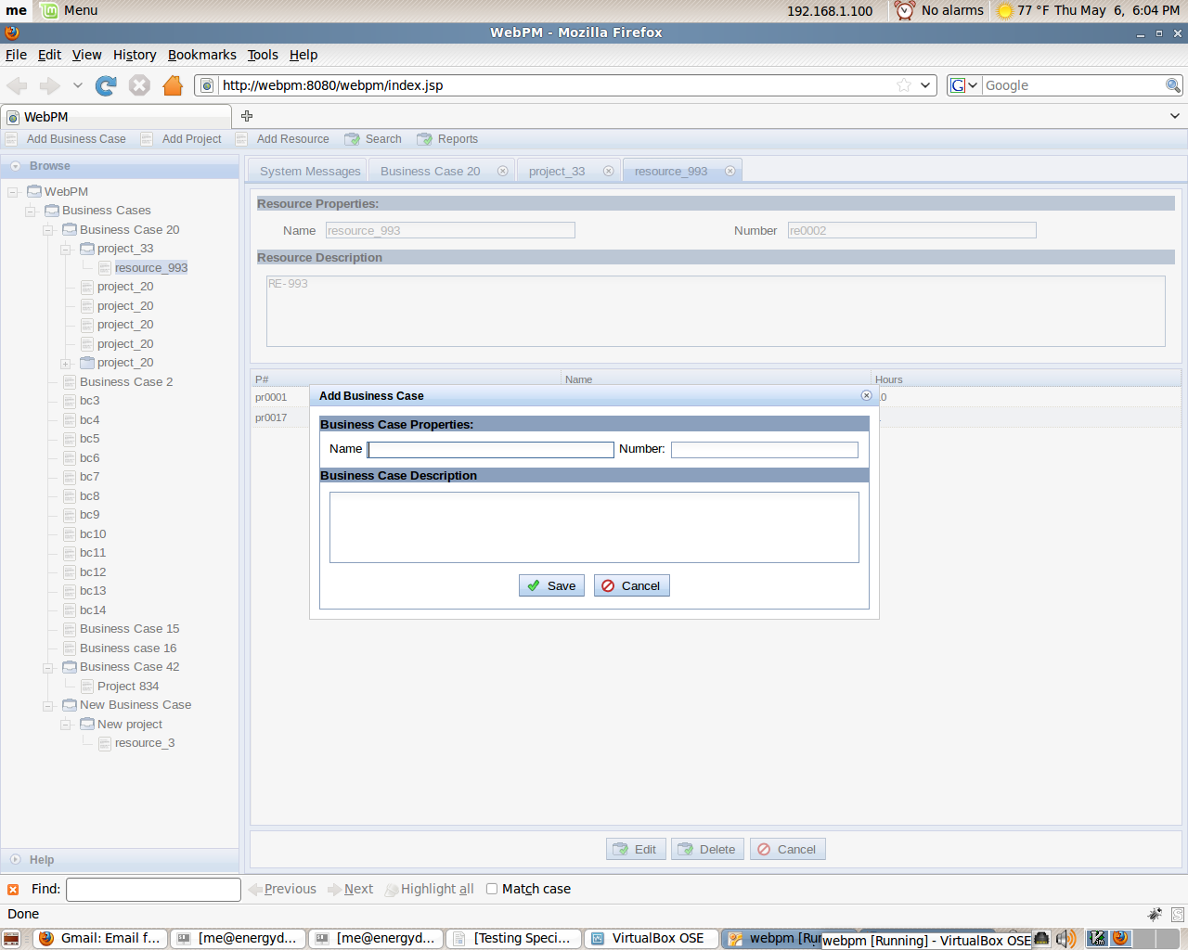
Complete the form by filling in the necessary data and click the “Save” button.
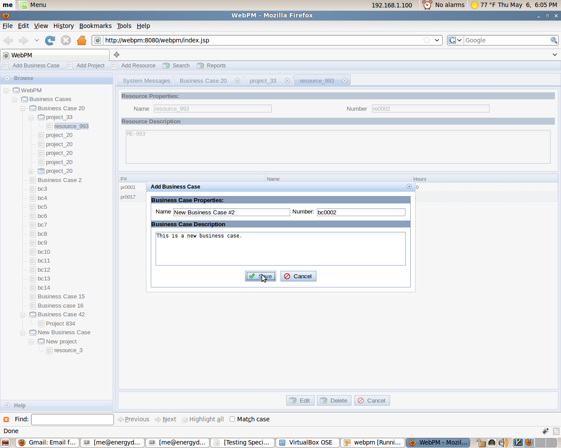
The business case should now be entered into the database and visible in the tree menu on the left side of the screen.
View:
To view a business case entered into the system, simply click on the business case you wish to view listed in the tree menu on the left side of the interface. The details of the selected business case should appear on the right side of the page.
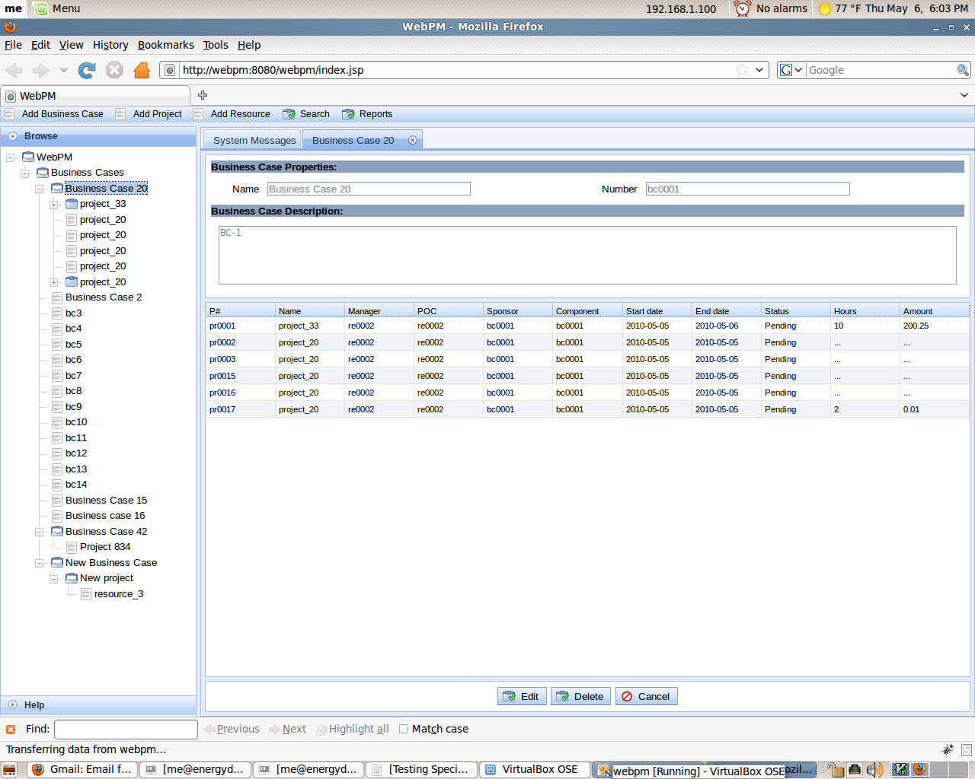

Edit:
To edit a business case, click on the desired business case in the tree menu on the left of the screen. When the right side of the screen is filled with the business case information, click the “Edit” button located at the bottom of the data.
Clicking the “Edit” button will bring all of the detailed information about the business case to display in an editable form.
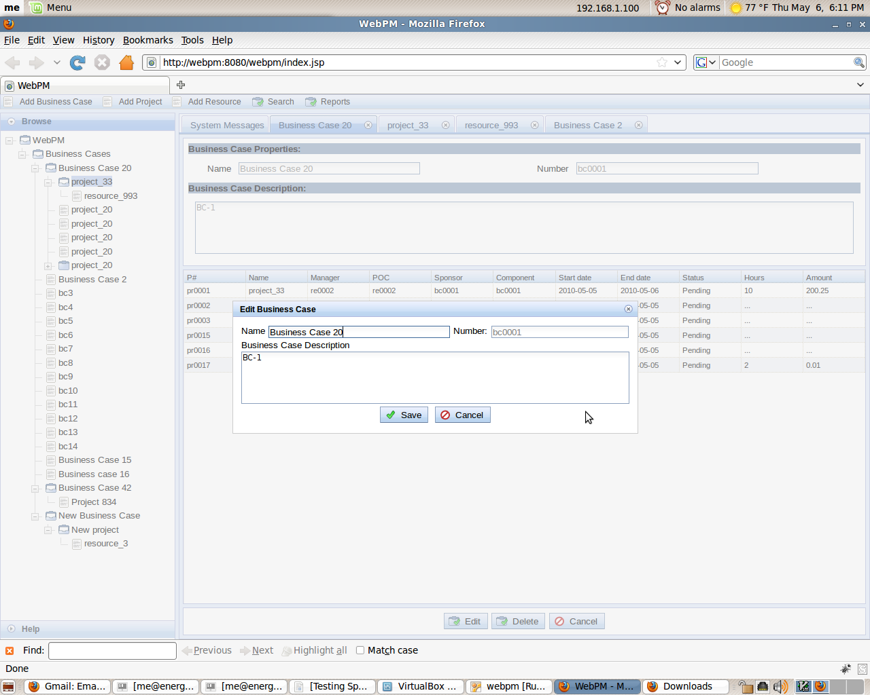
Edit the data presented as necessary and when finished, click the “Save” button at the bottom of the dialog.

Delete:
To delete a business case, click on the desired business case in the tree menu on the left of the screen to bring the details of the business case to the right of the screen. When the details are displayed, click the “Delete” button on the bottom of the display to delete the business case from the system.
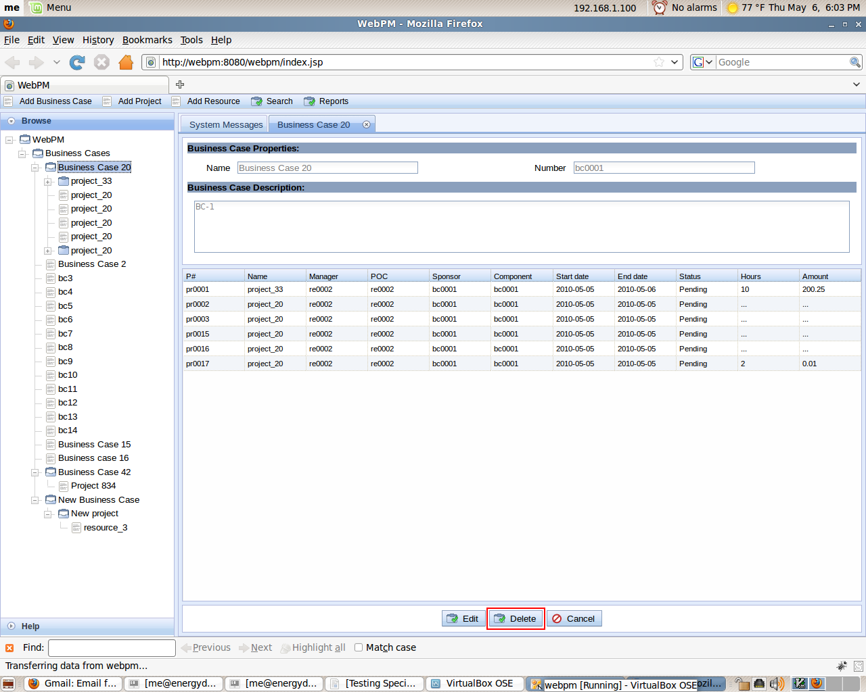

Projects

Add:
To add a project, click the button at the top left of the page titled “Add Project”.
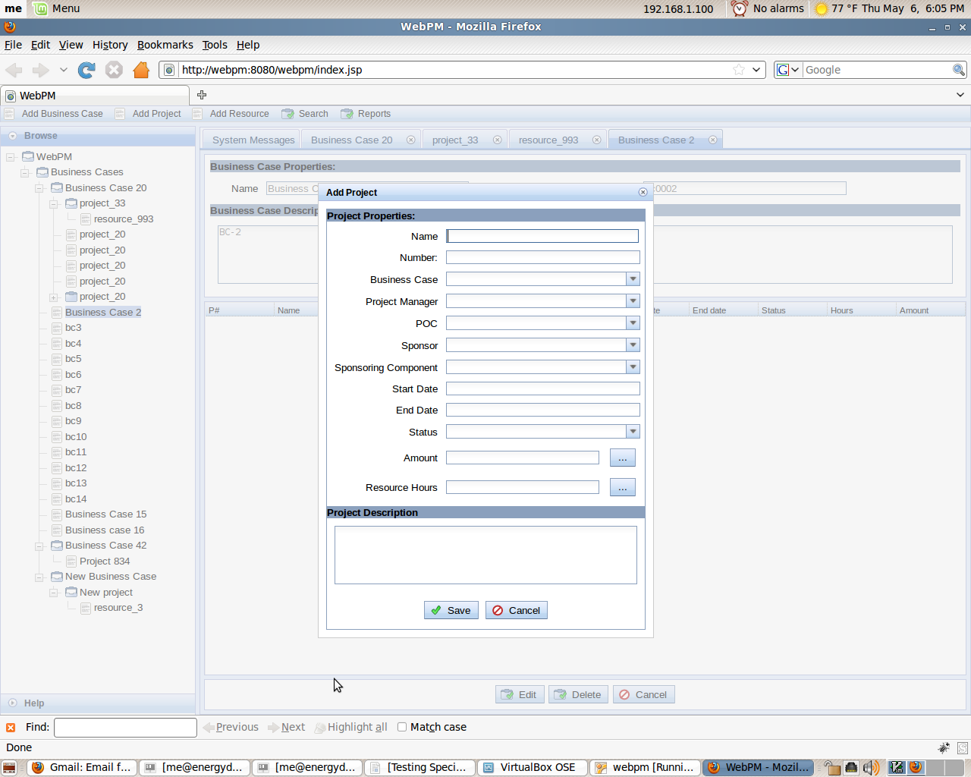
A dialogue window will appear containing fields for necessary information related to the project.
When adding a project, the user has the ability to assign resources and funding to the project when they are creating it.
To add a resource to the project you are creating, click the button located to the right of the “Resources” field.
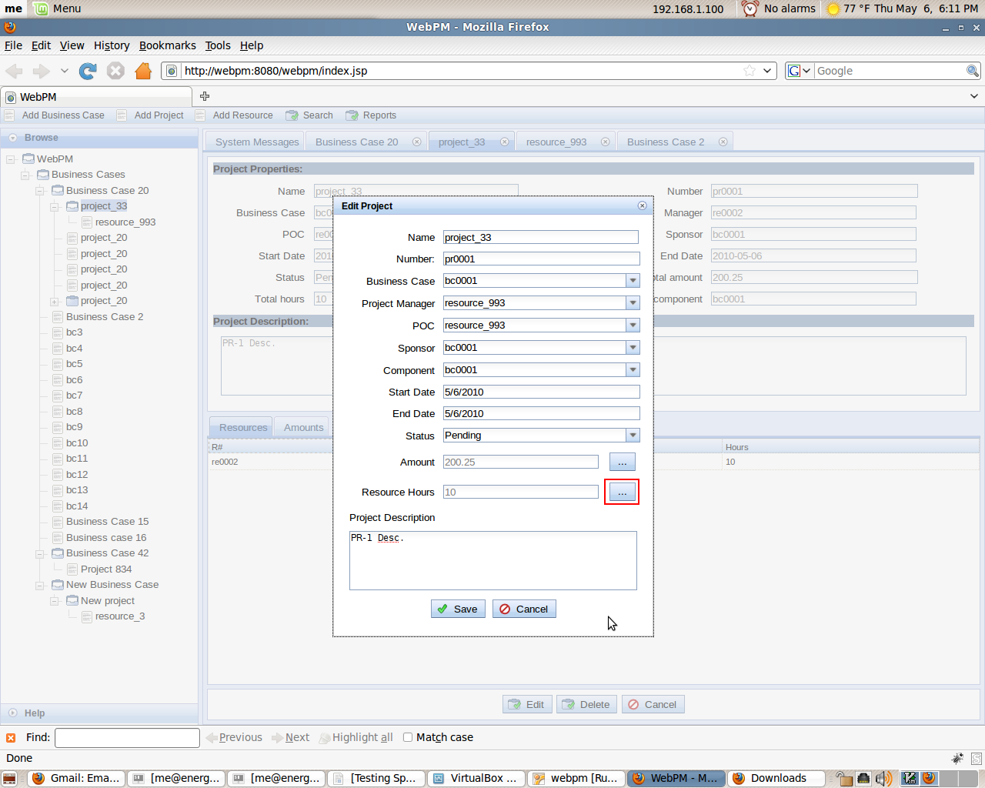

A new menu will pop up allowing you to add multiple resources and their assigned hours.
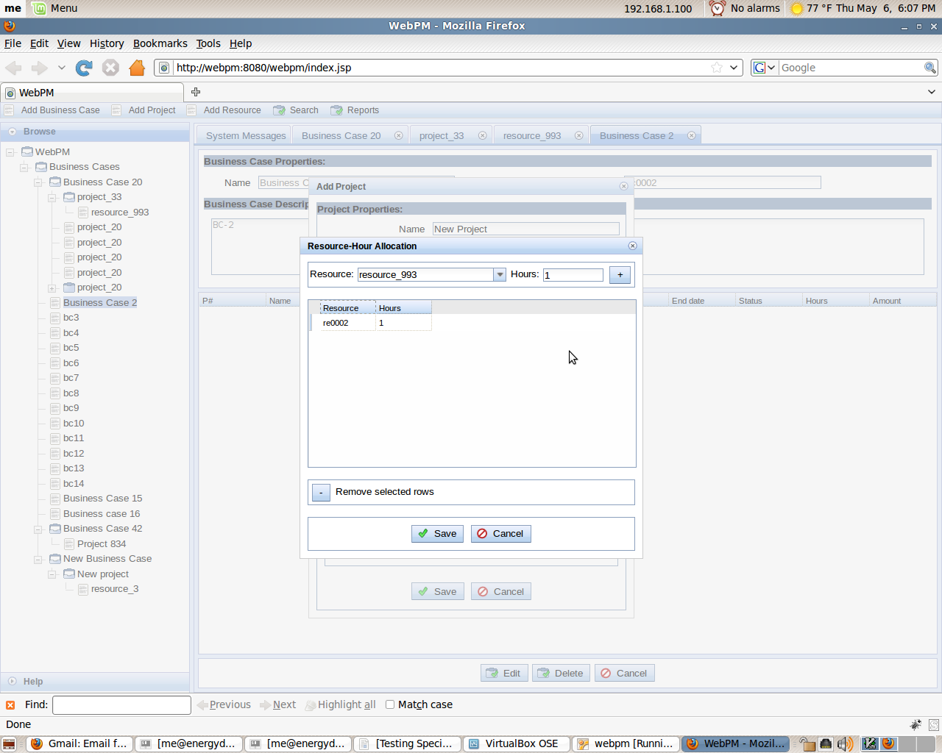

To add funding to a project, click the button located to the right of the “Amount” field.
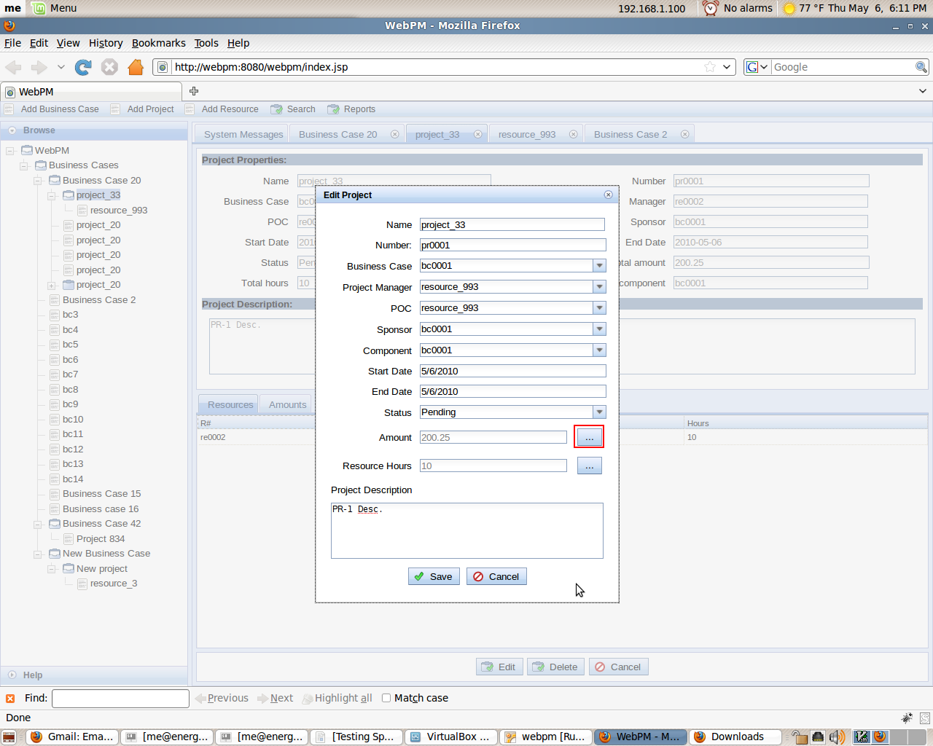

A new menu will pop up allowing you to add multiple monetary amounts for different years.
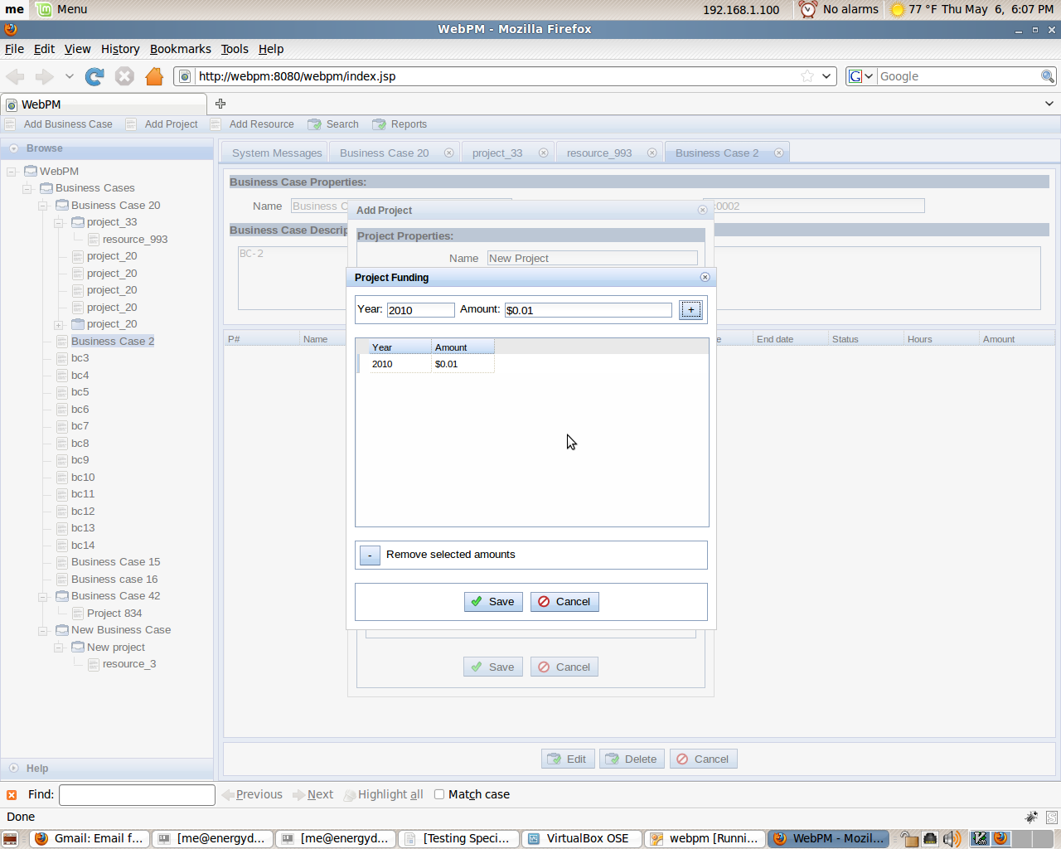
Complete the form by filling in the necessary data and click the “Save” button. The project should now be entered into the database and visible in the tree menu on the left side of the screen located under the business case it was assigned to.
View:
To view a project entered into the system, simply click on the drop down icon located next to the business case the desired project is assigned to. This will display the projects assigned to the selected business case. Click on the desired project you wish to view listed. The details of the selected project should appear on the right side of the page.
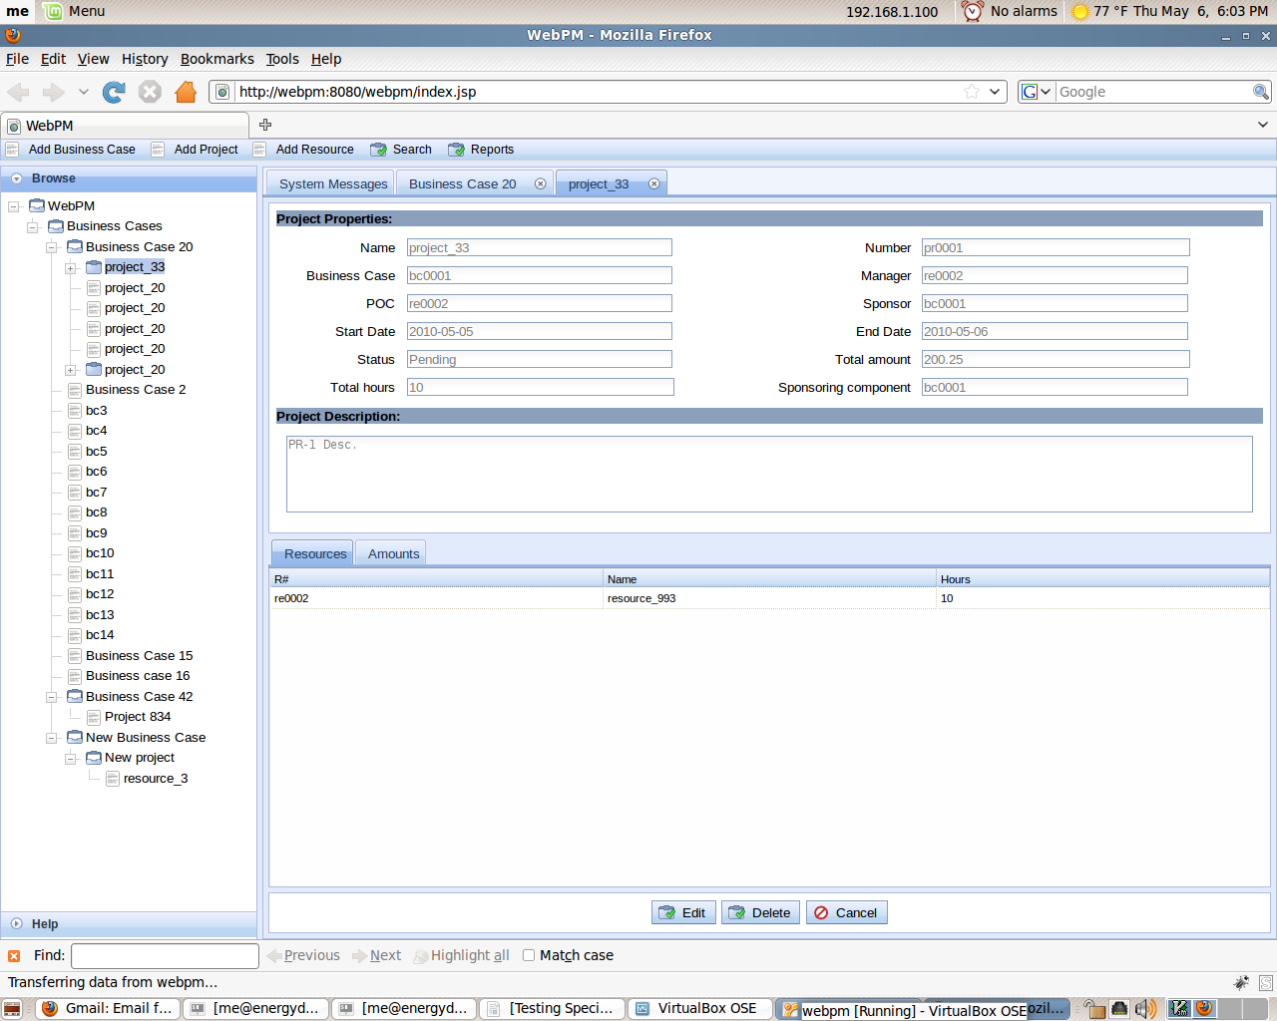
Edit:
To edit a project, click on the drop down icon next to the business case the project is assigned to in the tree menu on the left of the screen. Click on the desired project that will be visible under the assigned business case. When the right side of the screen is filled with the project information, click the “Edit” button located at the bottom of the data.
Clicking the “Edit” button will bring all of the detailed information about the project to display in an editable form.
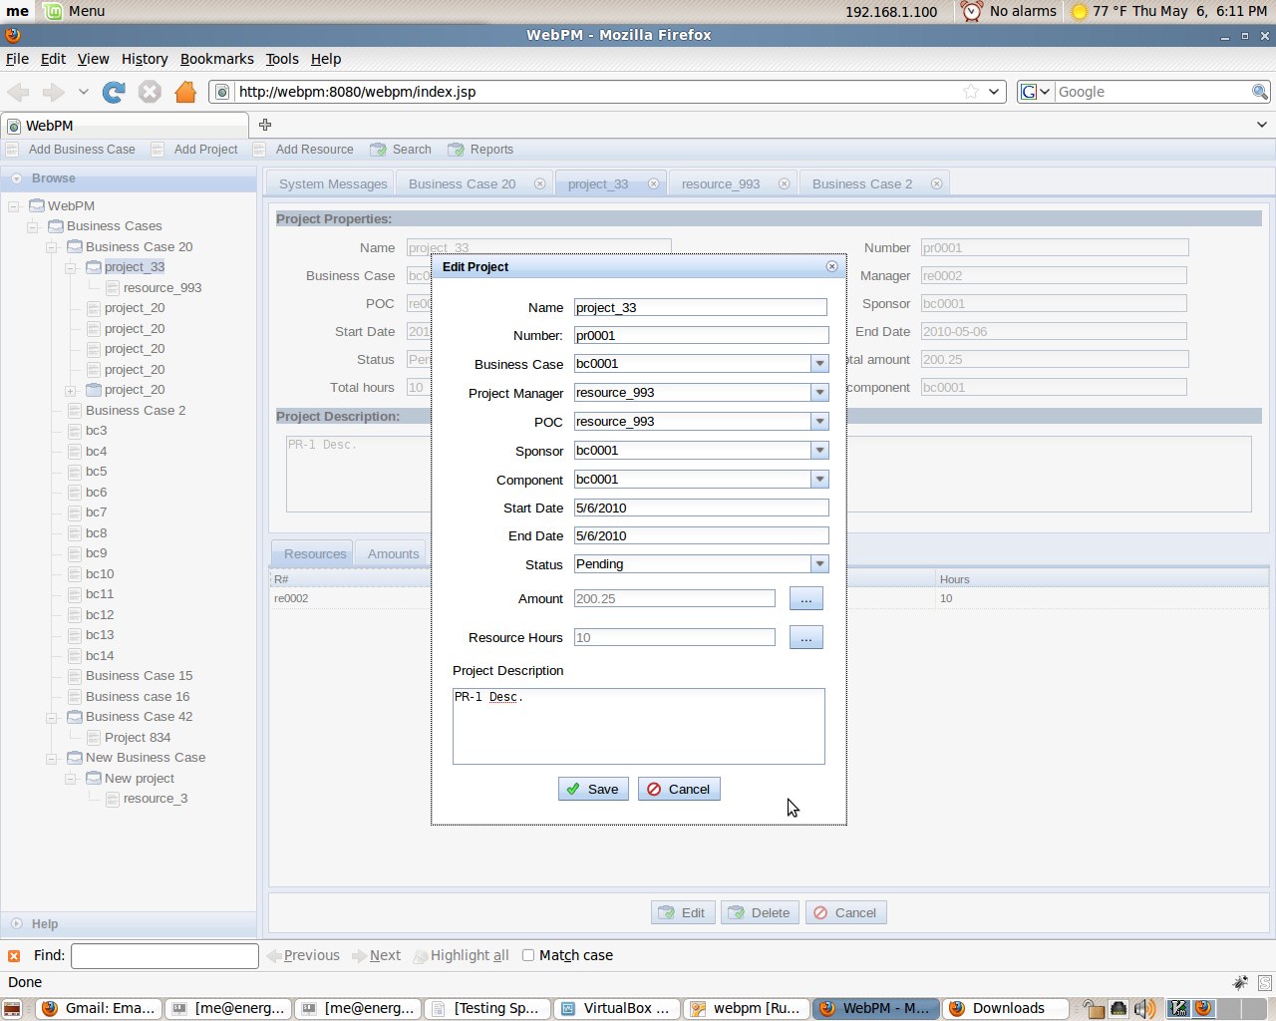
Edit the data presented as necessary and when finished, click the “Save” button at the bottom of the screen.

Delete:
To delete a project, click on the drop down icon next to the business case the project is assigned to in the tree menu on the left of the screen. Click on the desired project that will be visible under the assigned business case. When the details are displayed, click the “Delete” button on the bottom of the display to delete the project from the system.

Resources

Add:
To add a resource, click the button at the top left of the page titled “Add Resource”.
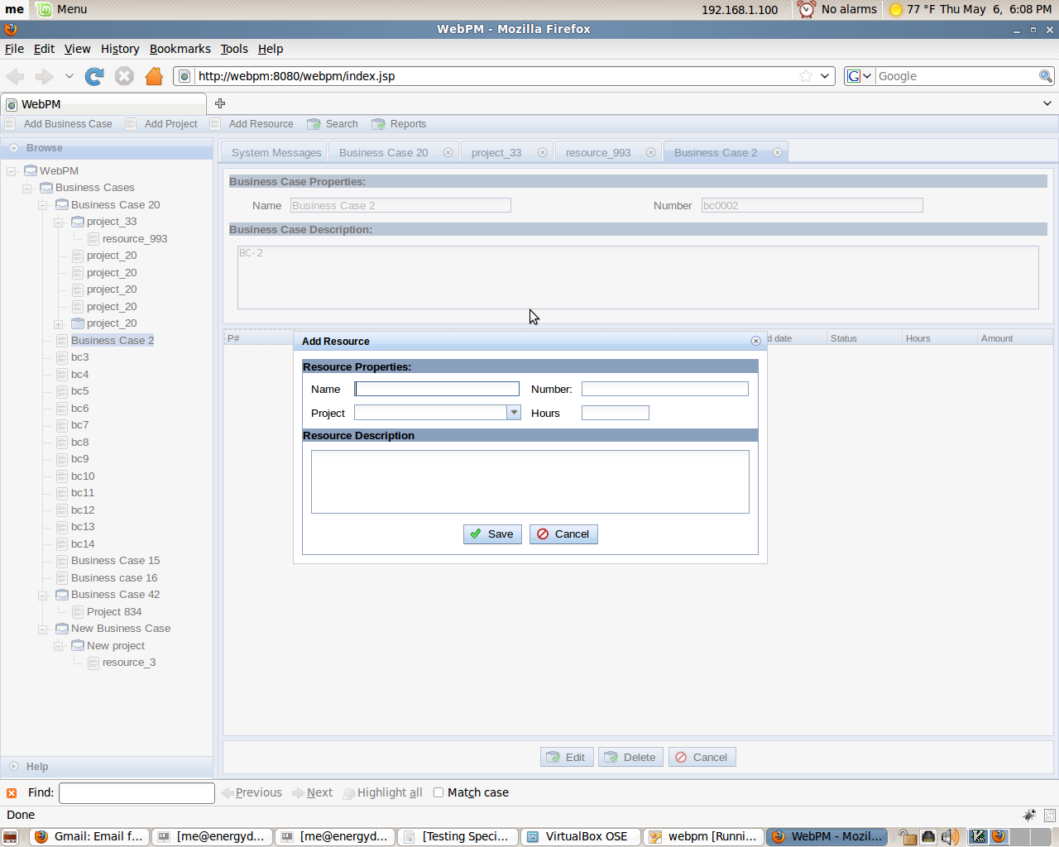
A dialogue window will appear containing fields for necessary information related to the resource. Complete the form by filling in the necessary data and click the “Save” button. The resource should now be entered into the database and visible in the tree menu on the left side of the screen under the project it was assigned to.
View:
To view a resource, click the drop down icon next to the business case to show all of the associated projects. Then, click the drop down icon next to the assigned project to see all of the resources assigned to said project. Click on the name of the desired resource to show detailed information to the right.
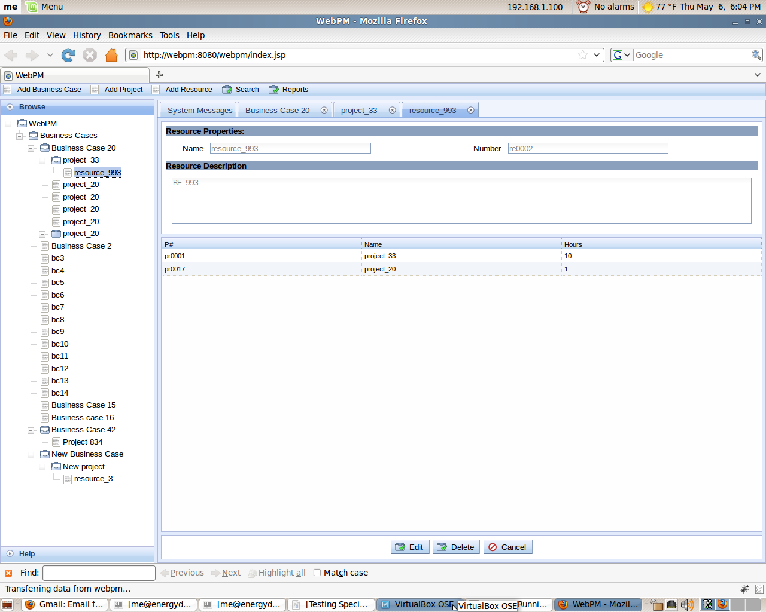
Edit:
To edit a resource, find and display the resource’s data through one of the methods described in the “View” section. When the data for the resource is visible, click the “Edit” button on the bottom of the page.
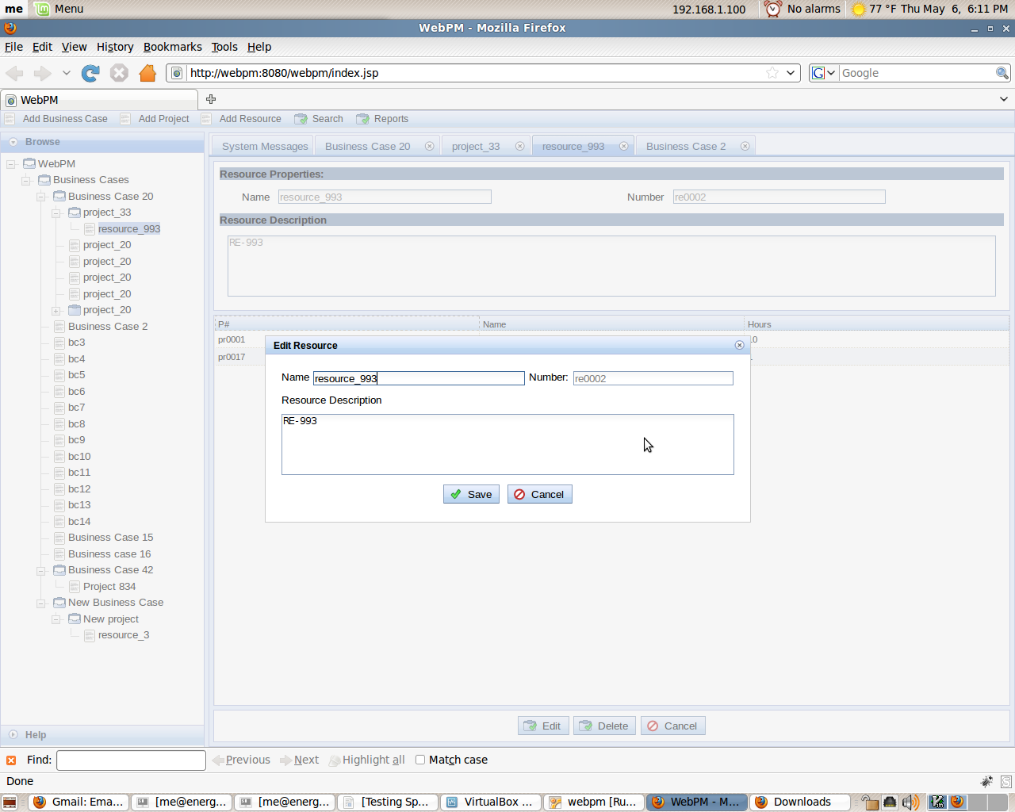
Clicking the “Edit” button will bring all of the detailed information about the resource to display in an editable form. Edit the data presented as necessary and when finished, click the “Save” button at the bottom of the screen.
Delete:
To delete a resource, find and display the resource’s data through one of the methods described in the “View” section. When the details are displayed, click the “Delete” button on the bottom of the display to delete the resource from the system.

Reports
In order to create a report, first click the button at the top of the page titled “Reports.”
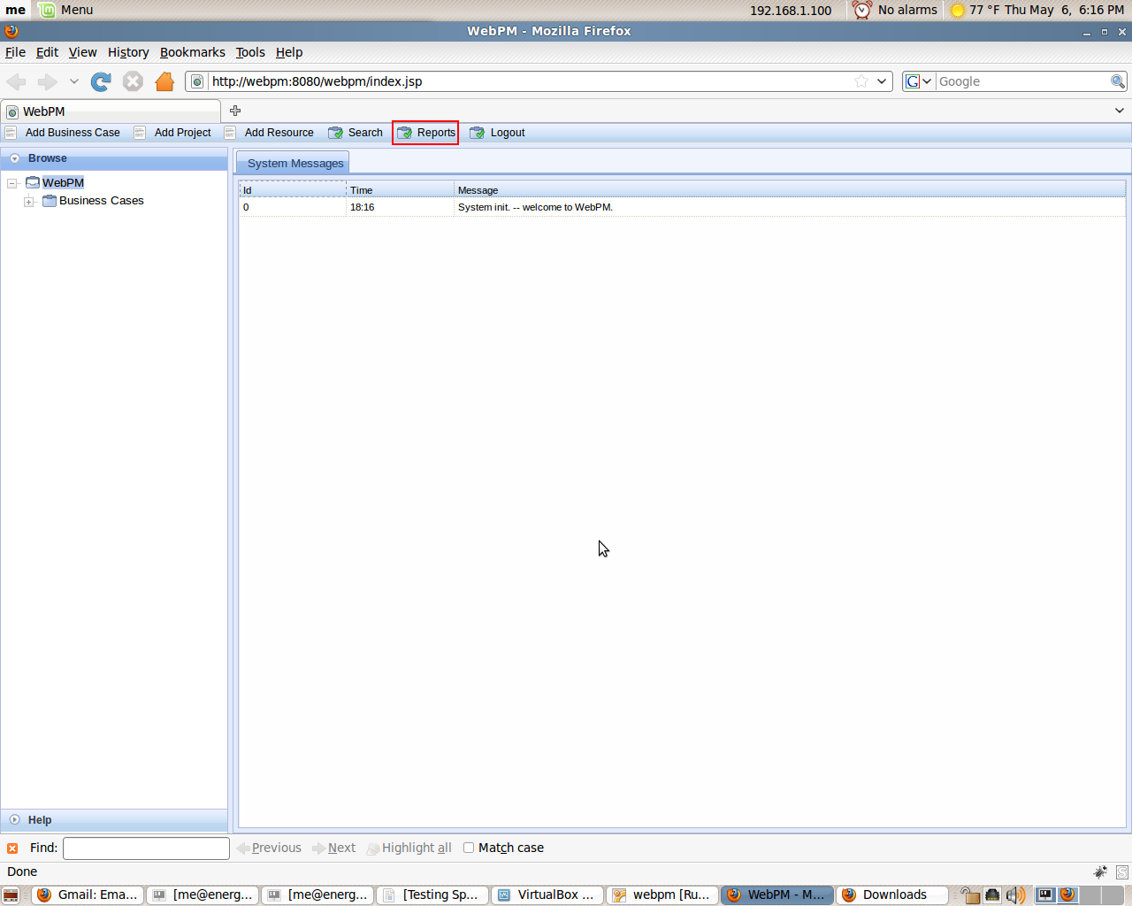
A dialogue window will appear containing fields to create specific reports. There are 3 different reports which take different parameters.
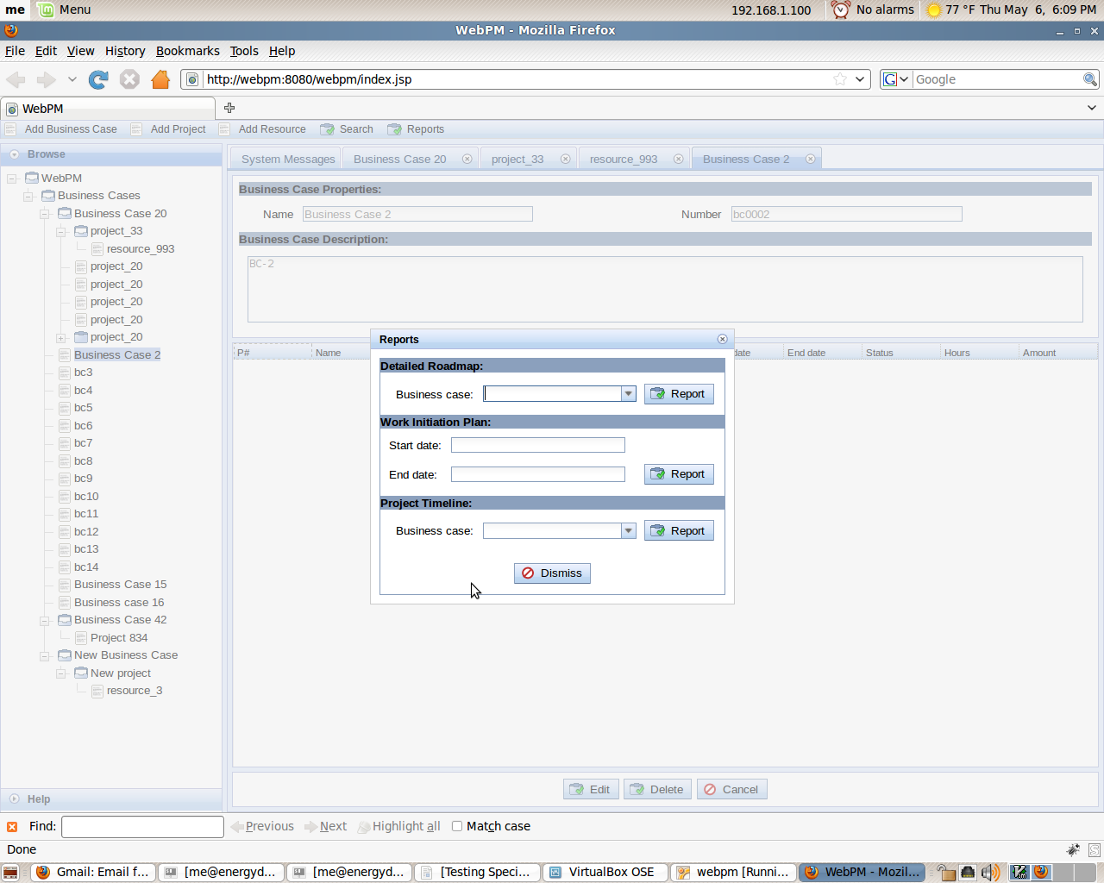
Work Initiation Plan
For the Work Initiation plan, a start and end date need to be defined. Clicking on the respective fields brings up an interactive calendar in which a date can be selected. If preferred, a date can be manually typed. After clicking the “Report” button located next to the fields, a report will be generated in PDF format and can be saved or opened in a preferred PDF reader.
The Work Initiation Plan displays the Projects that fall within the dates provided to the report interface. Projects that have Start and End dates that fall completely within the provided dates will be displayed closer to the top of the report. The report itself will display several fields related to Project information including the total amount of hours that Resources have been allocated to that Project.
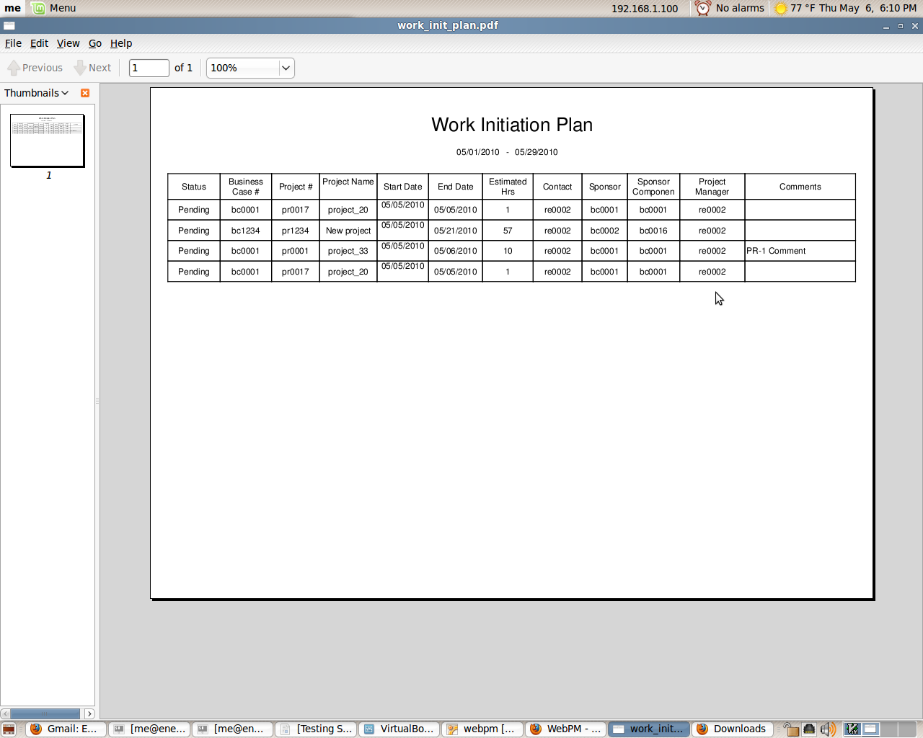
Detailed Roadmap
The Detailed Roadmap can be created by defining which Business Cases to include, or for all Business Cases in the database. The report will show all Projects within the defined Business cases and several fields of information about those Projects. The unique field for this report is the Cost field. This will total the amount of funds allocated for each fiscal year for that Project and display it. The total amount of allocated funds will also be displayed for each Business case.
Project Timeline
The Project Timeline needs no input. Just selecting this report and clicking “Report” will generate the PDF. This report displays the Timeline for Projects. Each Business case has its own chart which will display all Projects within the Business Case. Each line extends from the Project’s start date to the Project’s end date. The line is color coded based on the Project status.

